SKILL-20
- To Capture SIGTSTP, Suspend Processes, Update Job Table, Preserve State, Resume Later, Test Suspension Workflow.
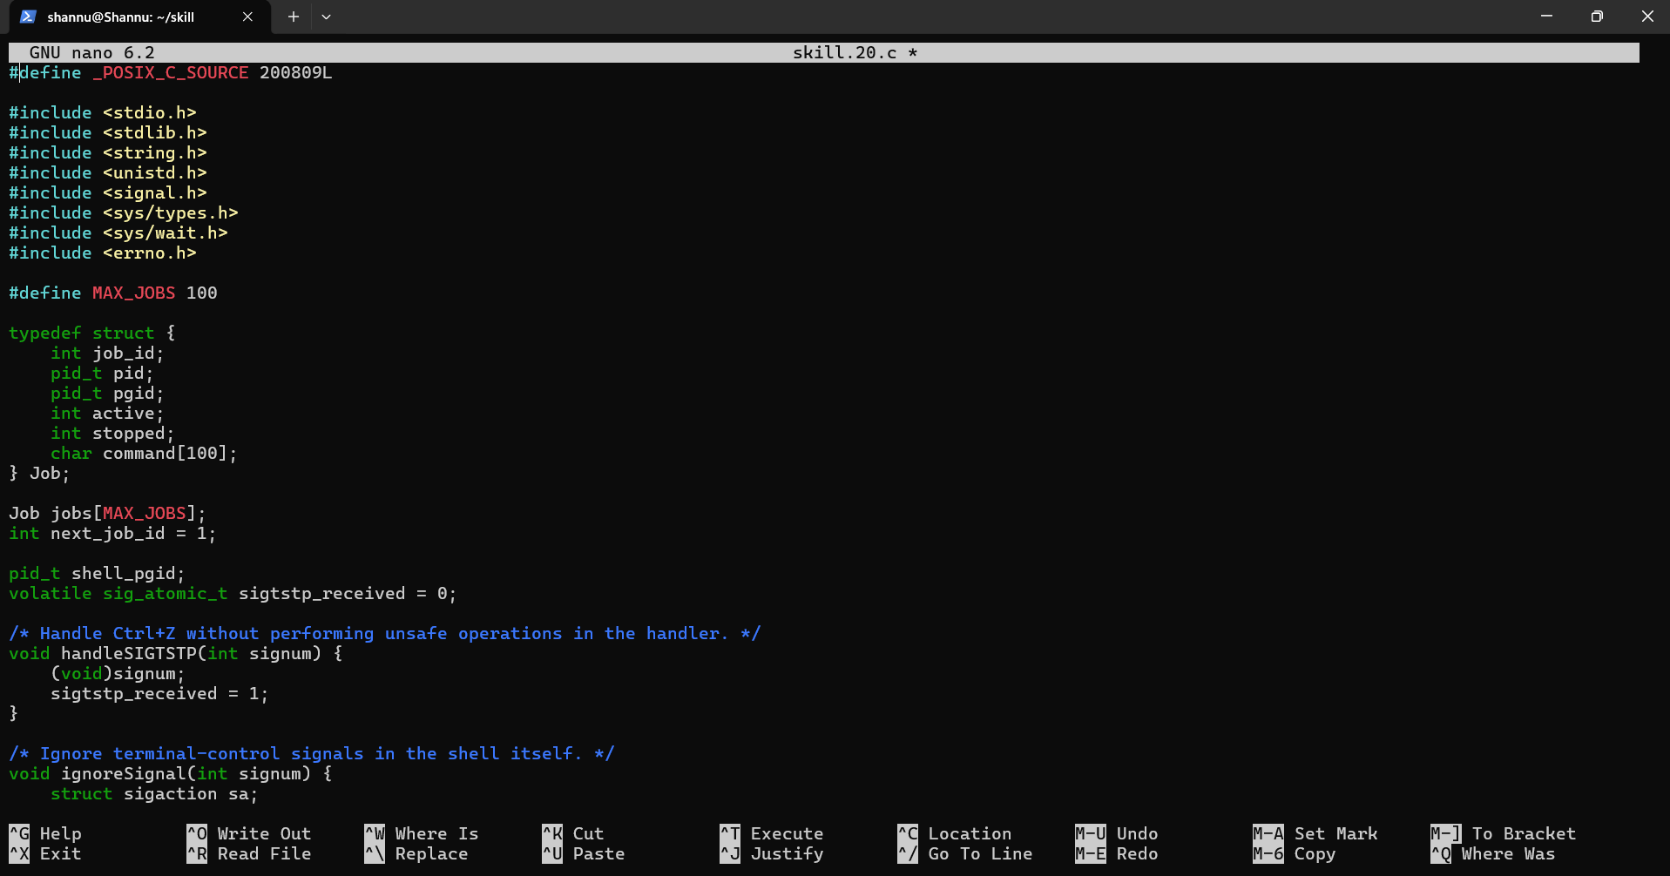
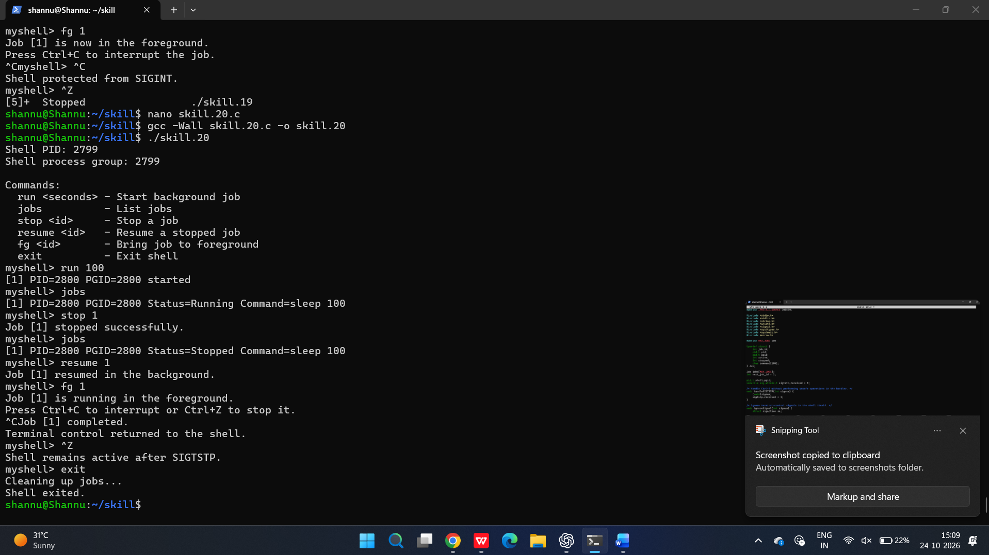
To Create Process Groups, Assign Group IDs, Transfer Terminal Control, Restore Ownership, Coordinate Signals, Validate Behavior.

